CALLALOO AND SALTFISH
Ingredients:
1 Large bag frozen callaloo
1/2 lb salt fish
½ cup olive oil
1 large onion
1 cup yellow, red, orange and green sweet pepper
2 cloves garlic
1 stark green onion
1tbsp. herbs basil, oregano, parsley, thyme, garlic chive, rosemary and leek (green)
1 tsp scotch bonnet pepper
6 - 8 allspice pimentos
3 small tomatoes
Seasoning salt and ground black or cayenne pepper as needed
Directions:
- Soak salt fish in water over night. Then cook it into fresh water to eliminate the salt.
- Strip the onion, green onion, and garlic, clean pepper and wash. Wash the green herbs.
- Then cut up all the wash ingredients in small pieces. Clean and wash the salt fish, then break it in small pieces.
- Turn on the stove to high heat. Put a medium skill on the stove with 1/2 cup olive oil to hot.
- Sauté onions, green onion, sweet peppers: green, yellow, orange and red, garlic, tomatoes and green herbs for 5 minutes.
- Add the salt fish and saute for another 3 minutes.
- Put callaloo in the pot with the sauté ingredients, and mixed all together.
- Add the seasoning salt, dried herbs, pimentos (whole and grind) and 11/2 tbsp. margarine to taste.
- Turn stove on low, cover and let simmer until callaloo is cook
Enjoy! By Celia Smith

Mario MckenzieView All Entries

The Health Benefits of Callaloo, A Jamaican Staple
- Posted by Mario Mckenzie January 16, 2019 - Filed in Health Dojo - #healthyfood #Callaloo - 7,518 views
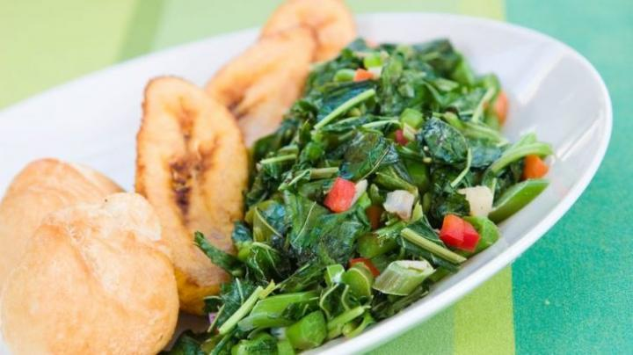

Callaloo, known in other parts of the world as collard greens, are a common sight in Jamaican cuisine, either as a side dish or as a main dish with pan-fried plantains. It is a dark green leaf that is related to kale and spring greens. Jamaican callaloo is prepared steamed or sautéed either alone or with other vegetables like tomatoes, onions, and peppers.
There are a range of benefits to eating callaloo on a regular basis. Before diving into the benefits, let’s take a look at some basic nutritional information.
Nutrition Facts of Callaloo:
Without taking into account other ingredients, one cup of callaloo cooked in water has:
  - 49 calories
  - 0g fat
  - 0g cholesterol
  - 9g carbs (3% DV)
  - 3g dietary fiber (21% DV)
  - 4g of protein
  - 308% vitamin A
  - 27% Calcium
  - 58% Vitamin C
  - 12% Iron
  - 1045% Vitamin K
  - 44% Folate
  - 41% Manganese
  - … many other vitamins and minerals

That is what you call a plant packed with nutrients! If you take a close look, one cup of callaloo is low in calories and carbohydrates, has no fat or cholesterol, and has significant amounts of fiber, protein and vitamins and minerals.
How can callaloo benefit your health?
  - Reduces risk of diseases like diabetes and heart disease
Hundreds of studies have focused on how an increased consumption of plant foods, like callaloo, throughout your lifetime can lead to a decreased risk of chronic diseases that could shorten your lifespan. This is due primarily to the fact that it is nutrient-dense, but energy-light. In other words, it is because it delivers a range of nutrients that contribute to overall health and well being, while not contributing significantly to caloric intake.
  - Helps to prevent bone fractures
If you glace at the nutrition facts again, you will notice that one cup of callaloo has a whopping 1045% daily value of vitamin K. People who experience vitamin K deficiency are also more likely to be at risk for bone fracture because it may reduce the excretion of calcium while improving its absorption into the bone, and because it may help to strengthen the bone matrix.
  - Helps to prevent Cancer
Nutritionists have known for years that consuming cruciferous vegetables, like callaloo, on a regular basis is associated with a lower risk of several types of cancers. This includes:
  - Lung cancer
  - Prostate cancer
  - Melanoma
  - Esophageal cancer
  - And pancreatic cancer
Callaloo, particularly, has high amounts of chlorophyll, which might help to block the carcinogenic effects of compounds found in grilled foods.
  - Healthy Skin and Hair
Callaloo has tons of vitamin A, which helps to keep your hair moisturized. It also helps to renew skin and hair so that you can keep that healthy glow and shine. Callaloo also has a significant amount of vitamin C, which helps to maintain collagen in your skin and hair, and iron, which can help to prevent hair loss.

